

7/13/2007 Version

APEX Drawing Basics
Table of Contents

Initial Setup …………………………………………………………………………………………………………………………………… 1

Cursor Modes …………………………………………………………………………………………………………………………………. 6

Unanchored vs. Anchored Lines ………………………………………..…………………………………………………………………… 6

Define an Area …………………………………………………………………………………………………………………………………. 7

Commonly Used Icon and Keystrokes ………………………….………………………………………………………………………….. 8

Print Preview …………………………………………………………………………………………………………………………………… 10

Subject Information ……………………………………………………………………………………………………………………………. 10

Save Drawing ……………………………………………………………..…………………………………………………………………… 11

Basic Drawing …………………………………………………………………………………………………………………………………. 12

Drawing Overhangs ……………………………………………………………………………………………………………………………. 15

Define the Second Area ………………………………….………………………………………………………………………………….. 16

Define a Third Area …………………………………………………………………………………………………………………………. 17

Edit Area Properties …………………………………………………………………………………………………………………………. 18

Draw Single and Multiple Free Form Lines …………………………………………………………………………………………………. 20

Auto-Trace ………………..………………………………………………..…………………………………………………………………… 22

Drawing Angles ……………………………………………………………..…………………………………………………………………… 23

Drawing Curves …………………………………………………………………………………………………………………………………. 24

Edit a Completed Area …………………..…………………………………………………………………………………………………….. 29

Special Drawing Conditions ………………………………………………………………………………………………………………….. 30

Auto-Subtract ………………………….………………………………………………………………………………………………….. 30

Duplicate Multiple Dwellings …………………………………………………………………………………………………………….. 32

Flip a Sketch …………………..………………………………………………………………………………………………………….. 34

APEX Function Keys …………………………………………………………………………………………………………………………. 35

APEX Quick Reference Guide to Most Commonly Used Processes ……………………….…………………………………………… 37

APEX Drawing Basics

Initial Setup

For consistency in drawings, your system should have the following settings:
Select Options / Default Directory / Area Code Table Location.
Make sure the Marshall & Swift / ORION code file (AXWDDA1.DAT) from H:\Orion\Apex has been copied into the location to the right. There is a default .DAT file by the same name that comes with APEX. The version on H: drive MUST be copied over the default file.
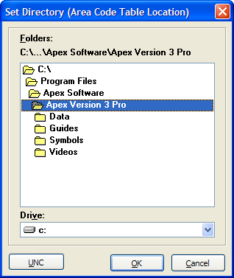
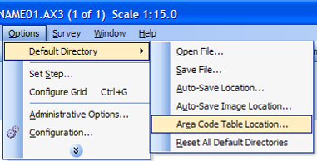

When you define an area, the Area Code Table should look like:
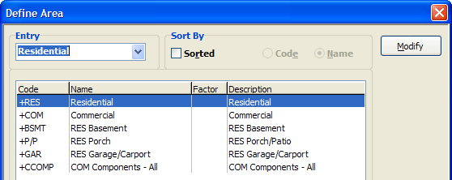

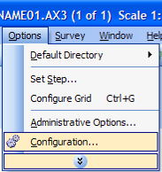 Select Options / Configuration…and make sure your system matches the following settings:

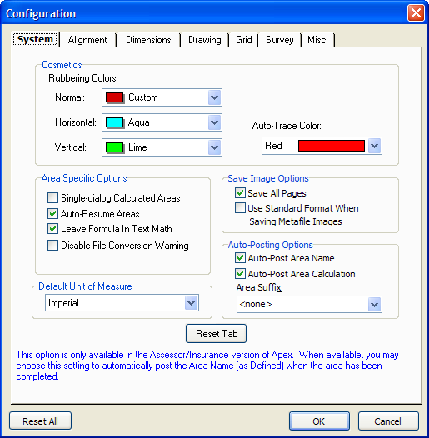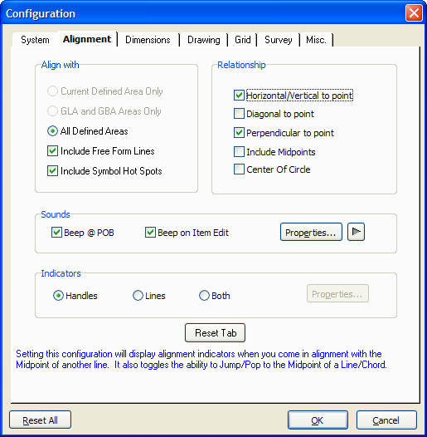
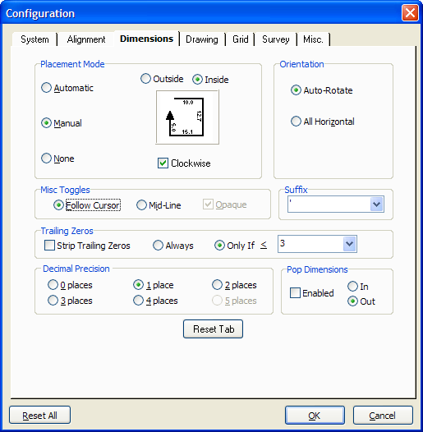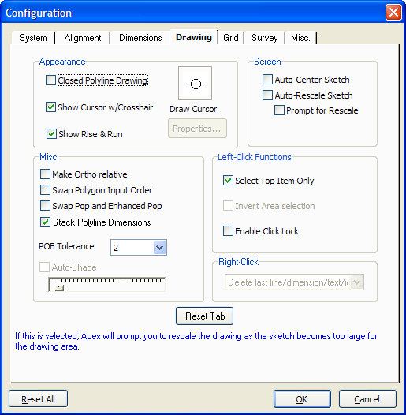
NOTE: Placement mode can be set to Automatic. This will change your keystroke entry to ACTION (i.e., 20 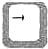) <ENTER> (only one <ENTER>). Both the line and the dimension will be anchored at the same time. You can edit the placement of the dimension numbers after the area drawing is completed.

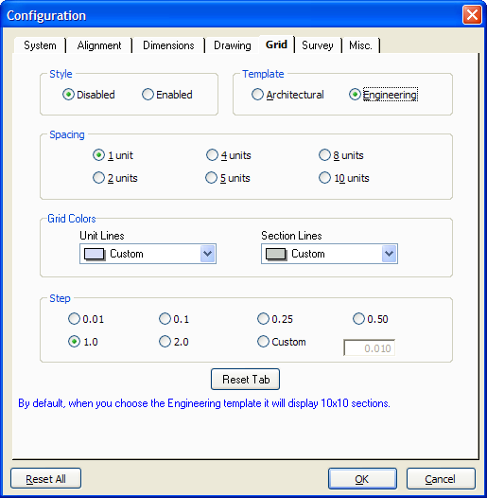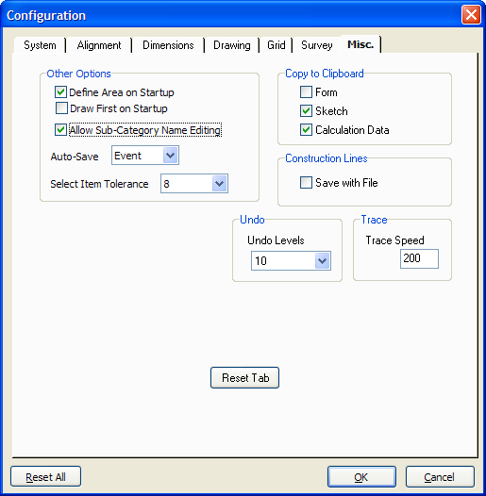

Display Setting
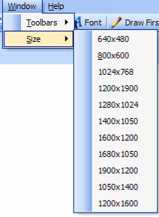
The optimum screen display setting is 1024 x 768. This allows you to read keystroke entries at the bottom left side of the Apex screen. To set the display:

Add common text words
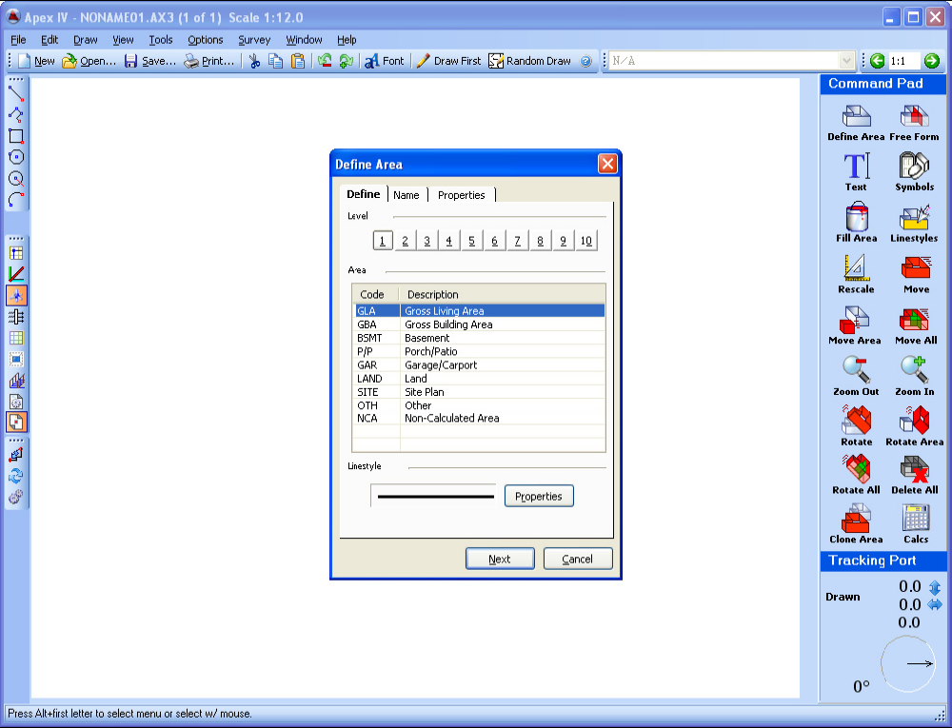 Select the Text icon from the Command Pad. 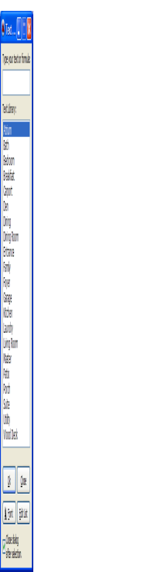 Select Edit List.
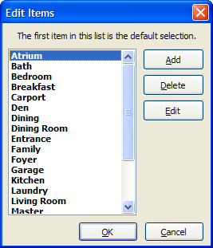

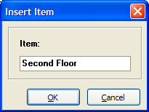

Select Add.

Type in the word(s) and select OK. Repeat until all common terms you have been given have been enter into the list.

Save File Default Folder
To save some time, you can set the default folder in which you want to save the file:
- Go to: Options / Default Directory / Auto-Save File
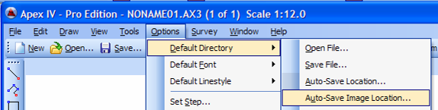
- Select the specific folder location you are working in (example: Residential Model 12, Neighborhood 063).
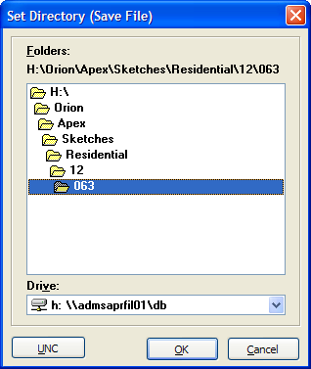
Whenever you save a file, it will take you immediately to that folder.
NOTE: Be sure to change the save file folder location when you change the neighborhood or model you are working with.

Open File Default Folder
To save some time, you can also set the default folder from which you want to open a file:
- Go to: Options / Default Directory / Open File
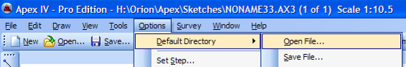
- Select the specific folder location. Because you may need to open files from previous neighborhoods and models, it may save time to set your default open folder to “Residential.”
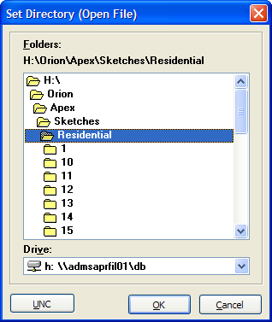
Line Style Default
If you want the lines that you draw for overhangs to be Dash 3 instead of a solid line, follow these steps:
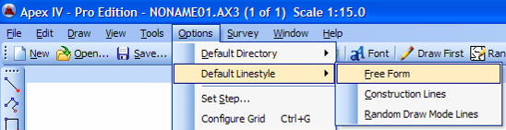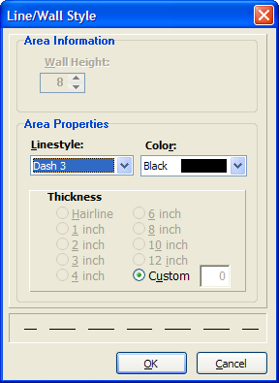
Cursor Modes
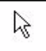 Pen-Up Cursor: Displayed on the drawing pad before taking any action.
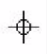 Pen-Down Cursor: Displayed when drawing perimeter lines, interior lines, or individual lines. Measurement inputs are expected by mouse or keyboard and line will be attached to the cursor until you return to pen-up mode. Enter Pen-Down mode by pressing <ENTER> or left clicking the mouse.
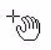 Movement/Monitor Cursor: Used when moving Defined Areas. The given area’s hotspot will be attached to the cursor until anchored in its new position. You can move the cursor from corner-to-corner by pressing <TAB>.

Unanchored vs. Anchored Lines
When lines are being drawn they are in an unanchored state and are, by default, agua, lime, or red in color. When unanchored, the objects can be changed in some manner whether it is line length, positioning, size, and so forth.
Agua denotes a line that is horizontal
Lime denotes vertical lines
Red denotes all others (some form of angle).
Once the desired line length is reached or the position of the object is satisfactory, press <ENTER> to anchor it. For example, when drawing a line:
- First define the areas to be drawn: .
- Enter Pen-Down mode (Left mouse click or press <ENTER>).
- Using keyboard entries or by dragging the mouse, specify the distance and direction (i.e., 20 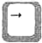). The result is:
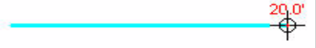 This unanchored line is still adjustable and inputs can still be made to alter its length and angle position (as is the case when drawing angled walls and rise-and-run).
- When satisfied with the length and position, press <ENTER> to anchor the line as follows:
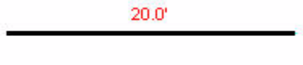 At this point, the line is anchored in place and can’t be changed unless an editing function is specified.
- When satisfied with the position of the dimension number, press <ENTER> again to anchor the dimension as follows:
At this point, the line and dimension are anchored in place and can’t be changed unless an editing function is specified.
After the dimension label is anchored, the program expects an input for the next line. If you move your mouse or use the keyboard to move the cursor, an unanchored line extends from the anchored line’s endpoint to the tip of the cursor.
If you bump or use the mouse and a short line appears before you can take the next action, press the 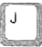 key to JUMP back to the next starting position and then enter your command.
J
NOTE: In most cases, your keystrokes will be: ACTION (i.e., 20 ) <ENTER> <ENTER> (in Manual Placement mode).
ACTION (i.e., 20 ) <ENTER> (in Automatic Placement mode).
Define an Area
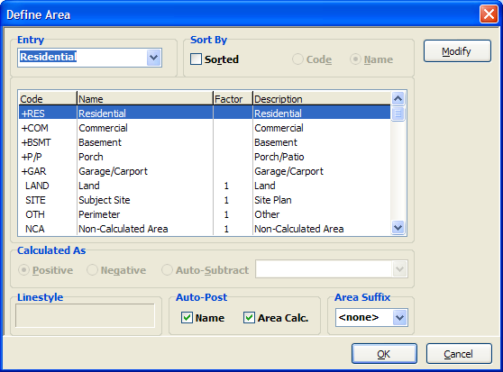
Defining the area is the most important concept to understanding Apex. If you haven’t changed the default settings, each time you open Apex or begin a new sketch file Apex prompts you to define and name the type of area that you wish to draw. The area definition is necessary for Apex to handle the distribution of area calculations on printouts and to pass data to integrated applications such as third-party URAR forms.
You can access the Define Area dialog at any time by pressing <F4> or by clicking the Define Area glyph located on the Command Pad on the top right side of the screen.

Highlight the area you want to draw, then click OK.

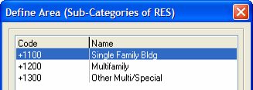
On the next dialog box, select the refined area of the initial area you selected. For example, (1) Residential, (2) Single Family Bldg.
Highlight your selection, then click OK.

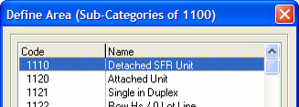
In some cases, you will access a third dialog box for one more refinement. For example: (1) Residential, (2) Single Family Bldg. (3) Detached SFR Unit.
Highlight your selection, then click OK.

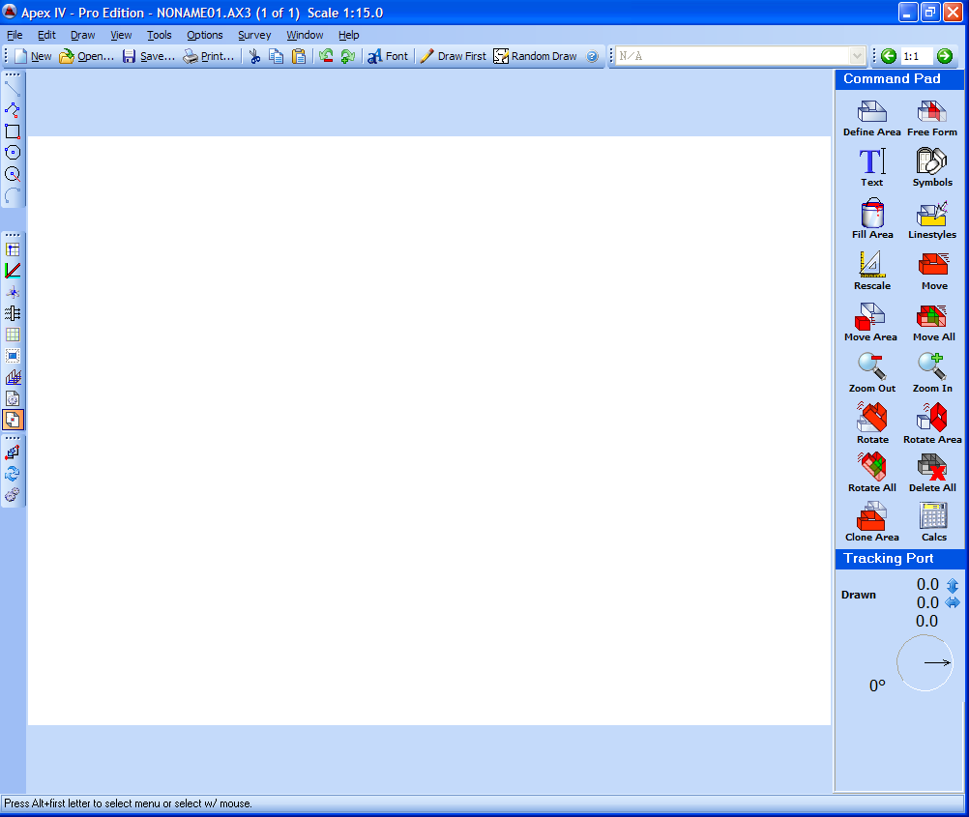

The drawing area will appear and you can select a starting location with the cursor arrow. Press <ENTER> or left mouse click to begin drawing the area you have defined.

Commonly Used Icons and Keystrokes
Undo. When an immediate error has been made, press the Undo icon to return to the beginning point of that action.

ICONS from Command Pad (upper right side of window):
Define Area. Select to describe area to be drawn.
Text. To add text to a drawing – either standard terms or custom terms.
Linestyles. To change the style of line used in a drawing – particularly when drawing a line to show an overhang area (highlight the line and select Dash 3).
Rescale. When your drawing gets too big for the page, select this icon to reduce the size of your drawing to fit better on the page. You can also increase the size of your drawing.
Move. This command allows you to move everything that has been drawn – including multiple separated drawings (such as Second Floor).
Move Area. This command allows you to move/reposition one area of a drawing (such as a porch or garage). Click inside the area you to move, then click on the Move Area icon.
Move All. This command enables you to move an area PLUS any additional text, lines or symbols that you added after the area was drawn.
Clone Area. This command allows you to make an exact copy of a specific area (such as the MFLA to use in drawing the second floor). Click inside the area you want to clone, then click on the Clone Area icon.
Calcs. This command brings up a summary of the calculations of each area you have drawn. It is used to verify that your drawing is accurate in terms of measurements.

ICONS from toolbar on left side of window:
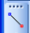 Single Line Tool. Select this option to draw a line – particularly a line to show the overhang area (be sure to change the line style after the line is drawn – see Linestyles above).
Sometimes the Draw Single Line tool is not available 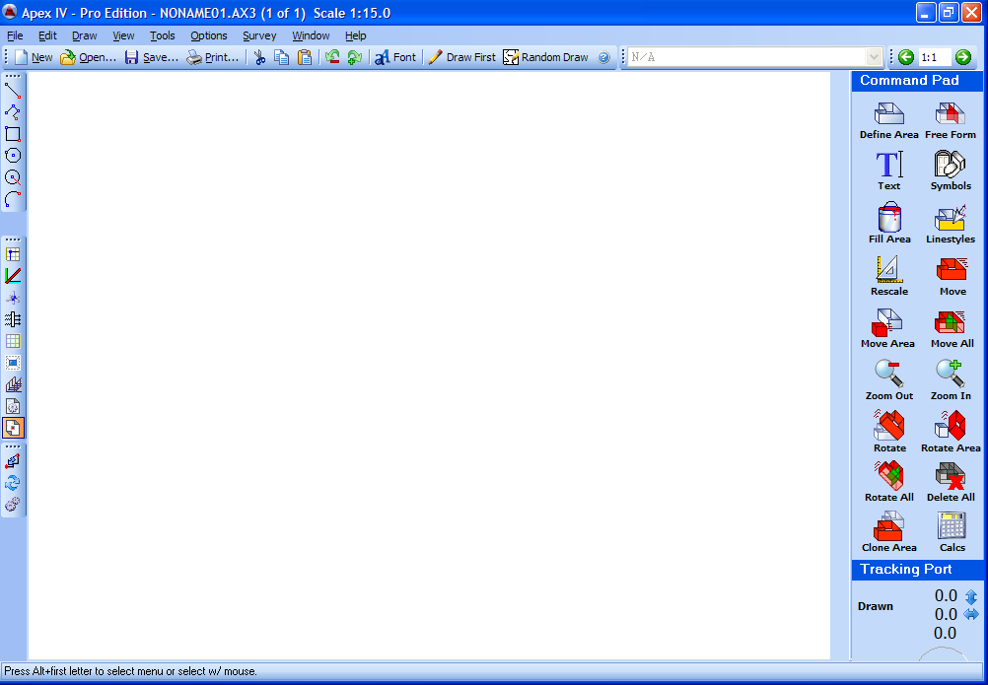. While this still may be a quirk in the system, there is an easier way to draw lines:
  - Press F5 to toggle between the description of the area you are drawing and Free Form Mode (viewed in the wide field in the upper right side of the window.
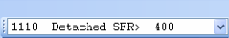 F5 to access 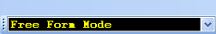 F5 to return to 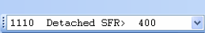
  - Once in Free Form Mode, draw the line, anchor it, toggle F5 to return to the normal mode, and then modify the line style if appropriate.
45 Degree Angle Tool. Select this option when any angles to be drawn are 45 degrees. This tool can be selected and deselected while you are in the drawing mode.
Swap POB (Point of Beginning) . This tool enables you to reverse the direction you are drawing. NOTE: When you reverse the drawing direction, you also reverse which side of the line the dimensions will appear on. When normally set to “Inside” (right side of line) going clockwise, swapping the POB will place the dimensions outside the area when going counter clockwise.
P
Alt
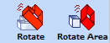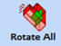 Rotate Tools.
When a Rotate command is used, it does not reach either straight vertical or horizontal. To reach straight vertical or horizontal when rotating an area:
While rotating an area or the complete drawing:
  - Press to snap the area to horizontal.
H
  - Press to snap the area to vertical.
V
  - Press to rotate in 45 degree increments.
R
  - Press to rotate in 5degree increments.
R
Shift
  - Press to rotate in 1 degree increments.
R
Shift
Ctrl
NOTE: Rotate Area and Rotate All work the same as Move Area and Move All described above.
OPTIONAL SETTING
When you elect to edit or clean up an area AFTER the area has been drawn (instead of while you are drawing the area), you can reduce having the press “ENTER” twice by doing the following:
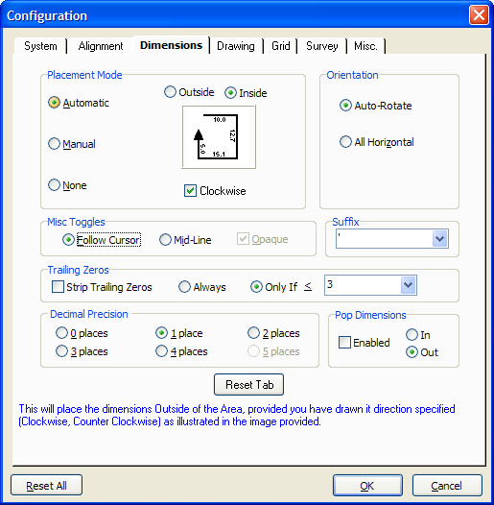
  - Go to Options, Configuration, Dimensions tab and change the radio button in the Placement Mode area on the upper left from “Manual” to “Automatic.” This will anchor the line and the dimension number at the same time – thus, only one “ENTER” is required.
Changes: Action (20 )<ENTER><ENTER>
To: Action (20 )<ENTER>

COMMON KEYS
Auto-Close Area. When there is only one line remaining to close the drawing of an area, press this key to close the drawing without having to draw the last line.
A
Close Bay Window. When the two sides of any extension are the same, press this key after the first two lines are drawn to replicate the side one line. Replicated line.
B
Center. Anytime during the course of drawing an area, press this key to center your drawing in the drawing area.
C
Jump to Point. Anytime you accidentally move the pen-down cross-hairs marker before you insert the next action, press this key to return to the next starting position. This is an important tool to make sure you are drawing an accurate area. When in doubt “Jump.”
J
Delete. If while drawing an area you notice an error in a previously-drawn line, press the <DELETE> key to back up to and remove that line. Each time you press the <DELETE> key, the previous line is erased. When in the incorrect line has been erased, simply re-draw the wall as usual with the correct distance and direction. Replace the remaining, deleted lines by pressing <INSERT> as outlined in the next topic.
Del
Insert. If the dimensions and directions of the drawn lines following the edited line are correct, press <INSERT> to restore the lines to the drawing. However, if your edited line changed direction you may need to redraw the lines following the edited line.
Ins
Auto-Trace. Refer to Page 36 of the Online Manual available in the Help Menu for details.
F3
Ctrl
Define Area.
F4
Toggle Free Form Mode to draw lines.
F5
Curve Properties. Select the style of curve you want to draw.
F7

Print Preview
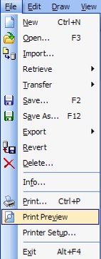
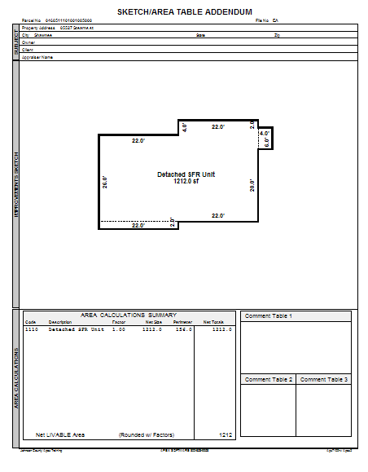
Make this selection to see how your drawing will look when it prints.
Be sure to rescale so that the main drawing is an easily readable size (fills most of the window).

Subject Information

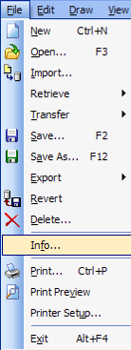
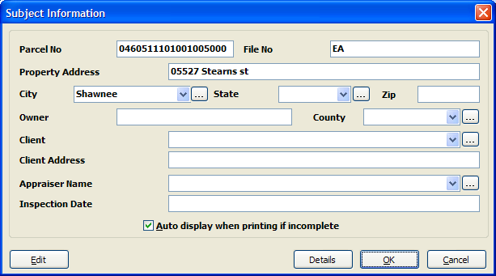
Enter the Subject Information from the worksheet used to create the drawing.

Select File / Info.

Save Drawing

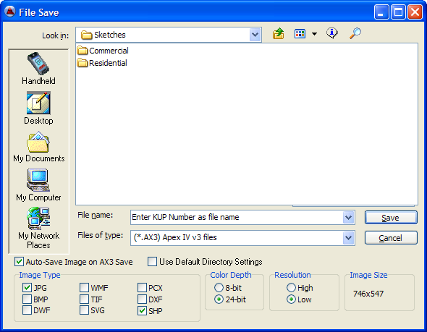

Be sure to check the Auto-Save Image on AX3 Save, JPG and SHP boxes before saving.
Also be sure to Uncheck Use Default Directory Settings
Enter the Property Number (KUP Number) as the file name. Apex will automatically add a -1 to the file name.
Be sure to select the proper folders before saving (i.e., H:\Orion\Apex\Sketches\Residential or Commercial\Model Number\Neighborhood Number.

Basic Drawing

Define an area as described earlier.
With the arrow in the drawing window, press <ENTER> to place the pen down (crosshair cursor). This first point is referred to as the Point of Beginning (POB) and you must draw back to this point to close the area so that it can be calculated. With the pen down (crosshair cursor), input 20 RIGHT and then press <ENTER> to anchor the line and <ENTER> again to anchor the dimension (necessary if manual dimension placement is on). With the first line and dimension anchored, the remaining three sides of the rectangle are drawn in the exact same manner. That is:
- Distance
- Direction
- Anchor Line
- Anchor Dimension
Draw the remaining 3 sides of the rectangle to close the area. The inputs for each of the lines of the rectangle are shown in the image as follows:

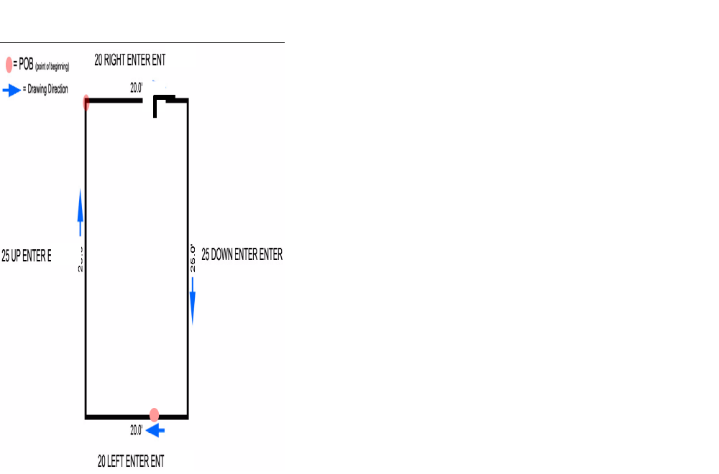

Note: As you input distance values, the Help/Status line (lower left) displays the inputs. If you make a mistake typing in the distance, press <ESC> to clear out the input and try again. If the line was drawn incorrectly (unanchored or anchored), press <DELETE> to incrementally move the cursor backwards towards the POB, removing the lines as you go.
Alternate Way to Draw a Rectangle
Define an area as described earlier.
While the pen is still in the Pen-Up position, type the width (20) times (x or *) the height (25), and then press <ENTER> only one time. This will create a red lined box:

If the box needs to be attached to another area (garage to a house), move the red lined box to its location with the mouse or use the arrow keys to move the box into position. Once in position, press <ENTER> to anchor the rectangle area.
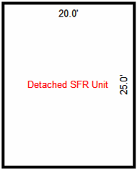
NOTE:
- When you create a rectangle box, only two of the dimension numbers are shown. You do not need to create the other two.
- If you need to edit the rectangle later, be aware that the drawing direction will be counter clockwise and your dimension numbers will place outside of the area unless you press or activate to swap the POB.
P
Alt

Define a new Area (Residential / 1100 / 1110)
Now position the cursor in the approximate center of the Drawing Pad and establish the POB by pressing <ENTER>. The cursor mode is now Pen-Down (crosshair) and the program expects the first measurement input. Completely draw the area using the inputs illustrated below. Remember, the first <ENTER> anchors the line and the second anchors the dimension. While drawing, you will notice that whenever the cursor is aligned with another point in the sketch, the points are highlighted. This indicates a vertical or horizontal alignment with any existing points in a sketch.
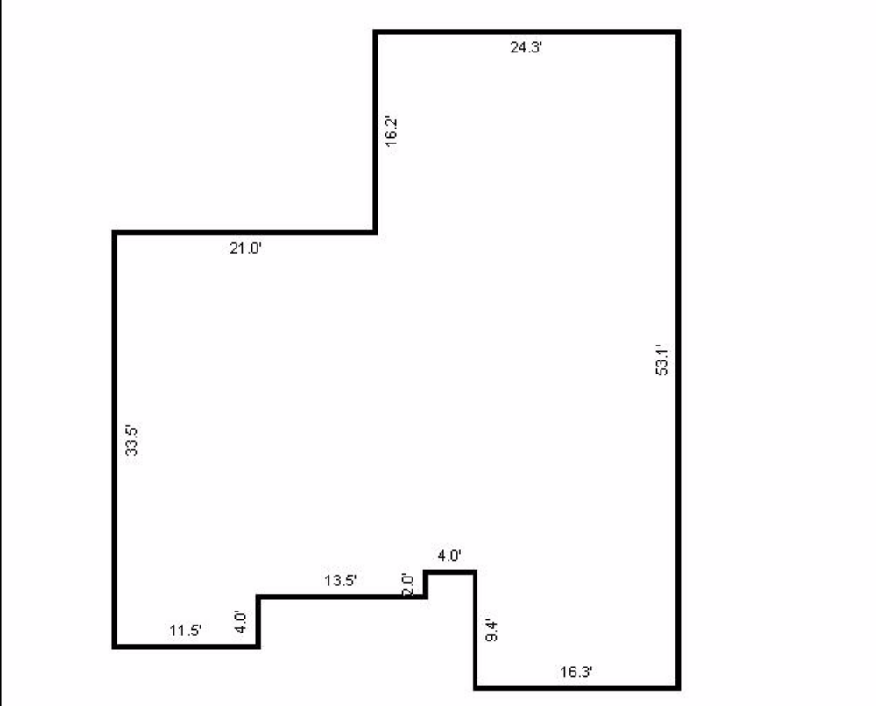
Input the following from the POB:
33.5 UP <ENTER>
21 RIGHT <ENTER>
16.2 UP <ENTER>
24.3 RIGHT <ENTER>
53.1 DOWN <ENTER>
16.3 LEFT <ENTER>
9.4 UP <ENTER>
4 LEFT <ENTER>
2 DOWN <ENTER>
13.5 LEFT <ENTER>
4 DOWN <ENTER>
to Auto-Close the area.
A
Drawing Overhangs
An overhang is any living area that does not have a foundation below it (such as a bay window or a bedroom extension over the garages on a split level home).
First floor overhangs are included as part of the MFLA (Main Floor Living Area). They are not drawn as separate additions (as done in the old CAMA system using vector strings).
Old System: Overhangs separate from the MFLA (MFLA = 984 square feet)
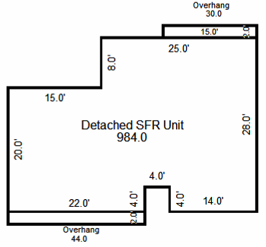
A0
A1
A2
New System: Include overhang dimensions as part of the MFLA (MFLA = 1058 square feet)
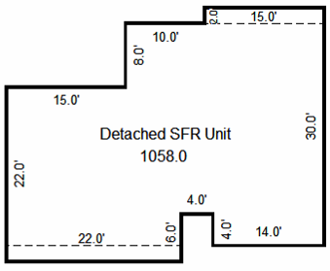
Draw a line to indicate the overhang area (For additional instructions, go to Draw Single and Multiple Free Form Lines):
- Use the Single Line Tool or, press to toggle ON .
F5
- If there isn’t an obvious place to start drawing the line, determine the starting point for drawing the line by:
- Placing the arrow near the corner of the drawing and press for “Jump.” BEFORE entering the pen-down mode, arrow key up or down one time for each 1 foot of movement (press the arrow key twice for 2 ft).
J
- Then press <ENTER> for pen-down to begin drawing.
- Draw the line as normal (22 <ENTER>).
- Press to toggle OFF .
F5
- Activate the Line Styles Mode ( or ) if needed. Select Dash 3 for any overhang lines.
L
Define the Second Area
Now let’s add a garage to this floor plan. Press to invoke the Define Area dialog (DRAW>DEFINE AREA). From the Define Area dialog choose Garage/Carport from the list and press <ENTER>. Highlight “Attached Garage” and once again, press <ENTER> to accept the area name.
F4
If you have not moved the mouse, the cursor (Pen-Up) should still be at the POB of the first area.
If you have moved the cursor, reposition it at the POB of the first area.
J
Note: Press to make the cursor “Jump” to the closest endpoint. To use properly, move the cursor to the general vicinity of the endpoint before jumping by using your mouse or the directional keys.
Press <ENTER> to place the pen down. The garage dimensions are 20.2’ x 27.5’. So, input the following:
20.2 LEFT <ENTER>
27.5 UP <ENTER>
20.2 RIGHT <ENTER>
To close the area, input: 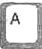 (Auto-Close) <ENTER>
A
Let’s make the sketch fit better in the Drawing Pad using the Rescale tool. Press 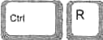 and choose 1’ = 10’. Press
C
R
Ctrl
to center the sketch. Now every part of the drawing, including dimension labels, is proportionally re-scaled.
NOTE: You can also rescale after one or more areas are closed by using the roller wheel on the center of the mouse.
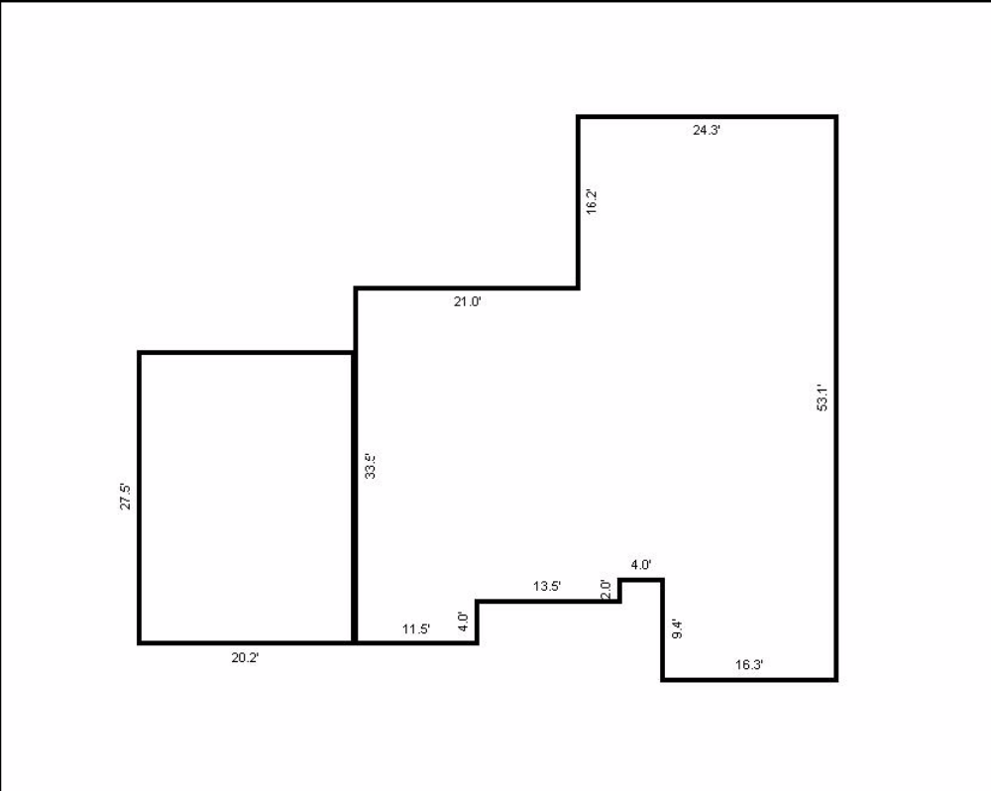
Define a Third Area
Now let’s add a deck to this floor plan. Press <F4> to invoke the Define Area dialog (DRAW>DEFINE AREA). From the Define Area dialog choose Porch/Patio from the list and press <ENTER>. Highlight Wood Deck and once again, press <ENTER> to accept the area name.
If you have not moved the mouse, the cursor (Pen-Up) should still be at the POB of the first area.
If you have moved the cursor, reposition it at the POB of the first area.
This time, you must locate the correct POB on the line at the right side of the drawing. The deck will commence 10 ft. down from the upper right corner of the drawing. There are two ways to reach the POB:
J
- Place the arrow near the upper right corner of the drawing and press for “Jump.” BEFORE entering the pen-down mode, arrow key down 10 times (the default movement setting is 1 ft increments. After 10 movements press <ENTER> for pen-down to begin drawing.
- This way is similar to #1, except that once you have jumped to the upper right corner of the drawing and BEFORE entering pen-down mode, type 10 . The cursor arrow will jump down 10 ft to the POB for drawing the deck. Press <ENTER> for pen-down to begin drawing.
The deck dimensions are 12 x 14. So, input the following:
12 RIGHT <ENTER>
14 UDOWN <ENTER>
12 LEFT <ENTER>
To close the area, input: (Auto-Close) <ENTER>
A

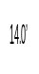
12.0’

Edit Area Properties
There may be times when you have selected the wrong code or forgot to write in the name of the area before you drew the area. Instead of having to delete the area drawing and start again, take the following steps to edit the area drawn so that the proper description shows up on the sketch and in the calculations.
- Highlight the area to be edited:
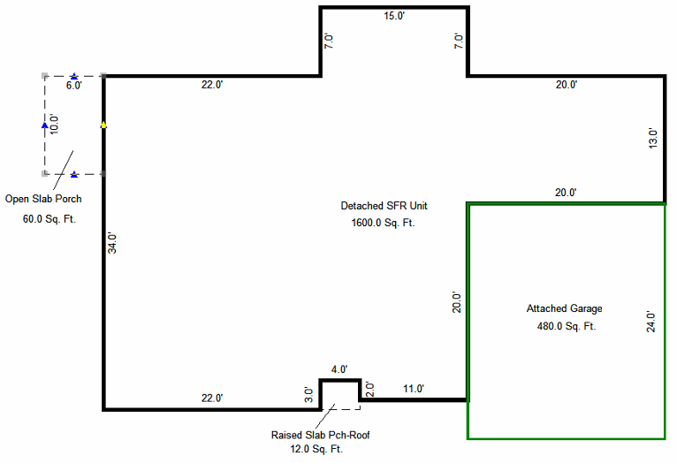
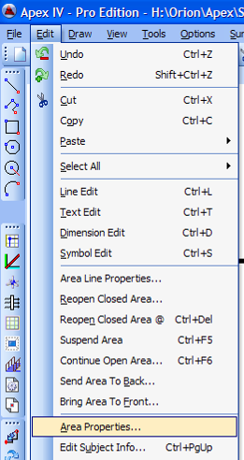
- Go to: Edit / Area Properties

- Select the correct code and description (write in the description name if appropriate)
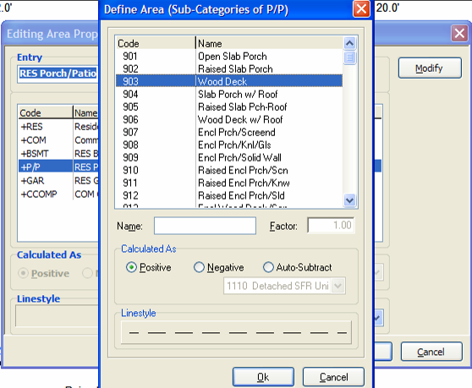
- Click “OK.” The correct code and description are now included in the sketch and the calculations.
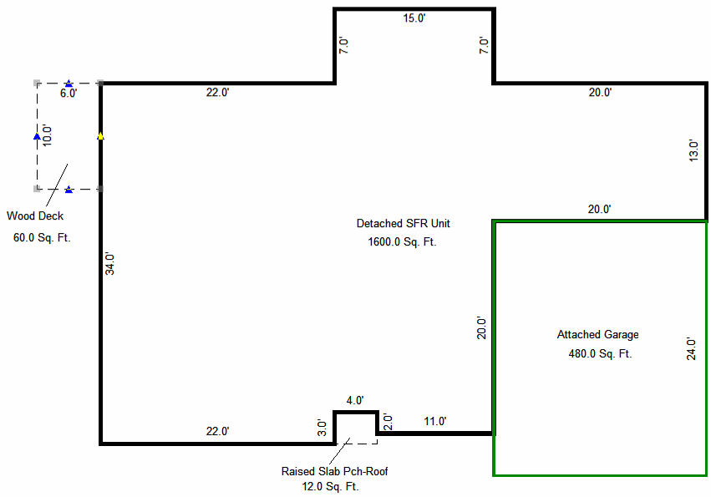
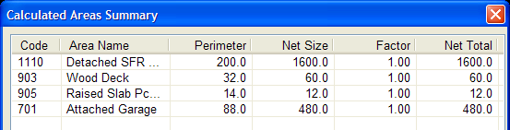

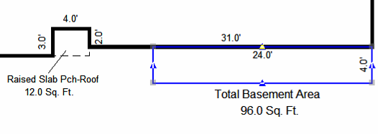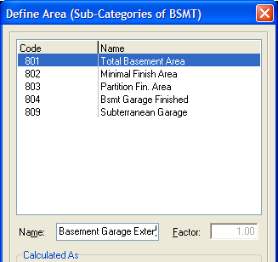

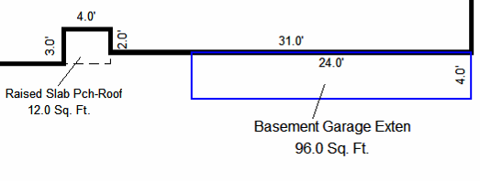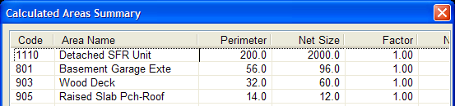

Draw Single and Multiple Free Form Lines
The quickest way to draw lines is to use the Free Form mode. You can use this mode to draw a single line or multiple lines.
- Press to toggle the on and off (once toggled on, it will remain in operation until it is toggled off).
F5
- Place the near where you want to draw a line and press to “jump” to reach the starting place.
J
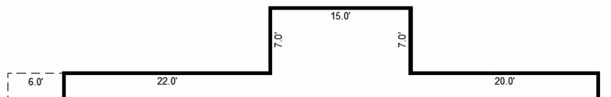

- Press to activate the pen down position ( ).
Enter

- Draw the line (with the mouse or the number and direction keys – 15 ).
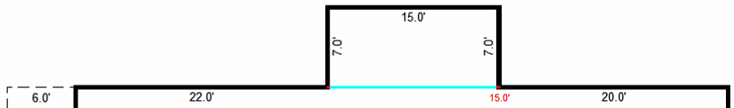
- Press to anchor the line.
Enter
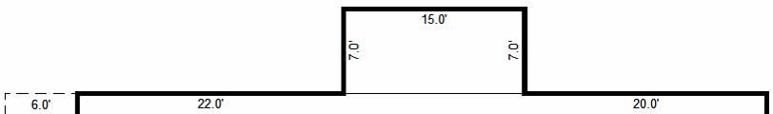
- Press again to return to the pen up position ().
Enter
- If there is more than one line to draw, repeat steps 2 – 6 for each additional line while still toggled on in the .
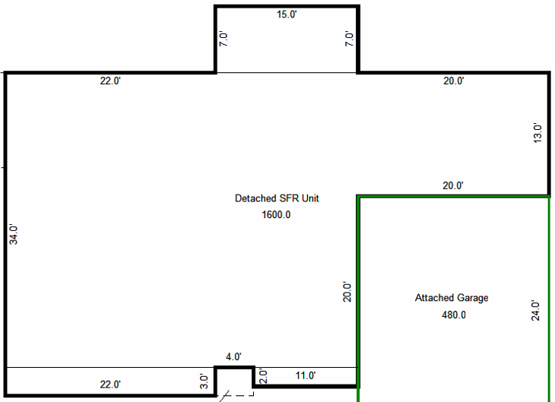
- When all lines have been drawn, press to toggle off of the .
- Highlight all the lines by holding down the key and clicking on each line.
F5
Ctr
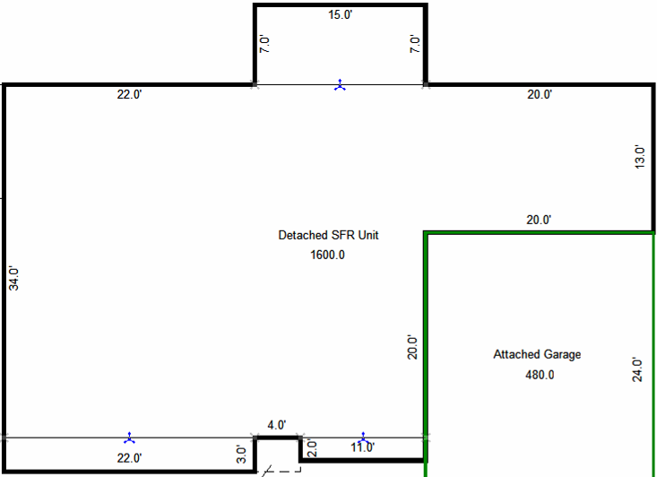
Make sure there is a blue triangle ONLY on the lines you have drawn (not the boundaries of any area).

- Activate the Line Styles Mode (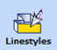 or ). Select Dash 3 for any overhang lines.
L
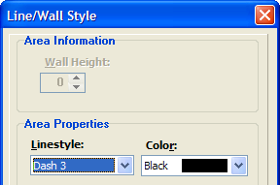
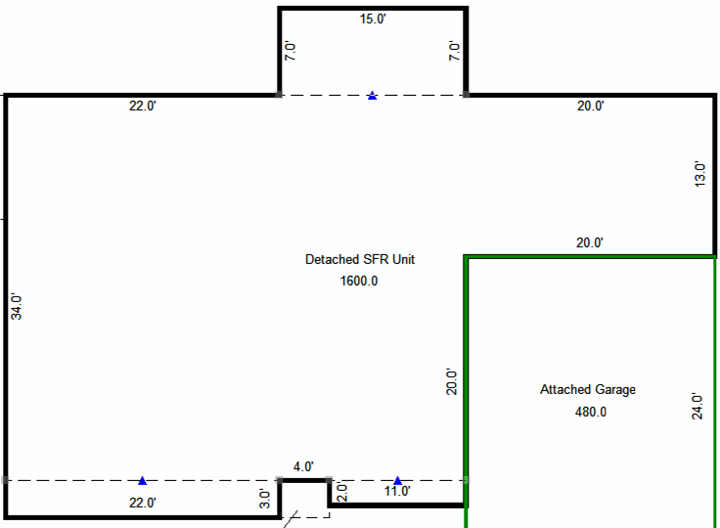
- Left Click the mouse outside of the drawing area or press to release the highlighted lines.
Esc

Auto-Trace
APEX will automatically Auto-trace when you first draw at least two unshared lines (Line 1 and Line 2 in illustration below). Even though there are two directions the Auto-trace could go, it will immediately follow the shared lines.
Line 2
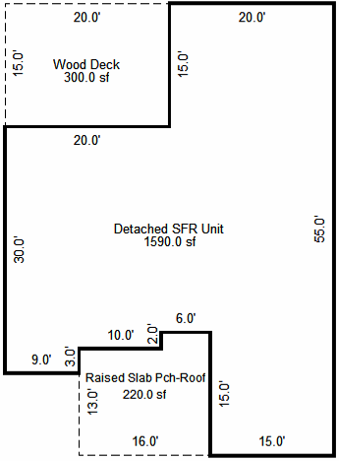
POB
POB
Line 1
Line 1
Line 2
15
20
Ctrl+F3 (Auto-Trace)
16
13
Ctrl+F3 (Auto-Trace)

Drawing Angles

Standard Angles
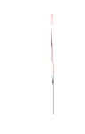
There are two simple ways to draw an angle:
- Rise and Run: Enter the Rise (4 ) and the Run (4 ) BEFORE pressing <ENTER><ENTER>.

- Distance, Direction and Deflection:
- Enter the length of the angle/wall: 15.6
- Then enter the direction – using or keys (upper or lower case), not the direction arrows:
L
R
L
- The enter the deflection (degree of angle): 50
- Then click <ENTER>< ENTER> (if set on “Manual” Placement Mode) or <ENTER> (if set on “Automatic” Placement Mode) to anchor the line.
15.6 50 <ENTER>< ENTER> 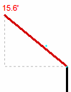 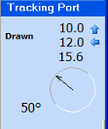
L
Before you anchor the angle, you can check in the Tracking Port box to verify the correct angle.

TURN Feature
After you have drawn an angle, you can use the TURN feature:
- Enter the length of the angle/wall: 25
- Then enter the direction – using or keys (upper or lower case), not the direction arrows:
L
R
R
- Then hit <ENTER> for a 90º turn (the default).
- Then click <ENTER>< ENTER> (if set on “Manual” Placement Mode) or <ENTER> (if set on “Automatic” Placement Mode).
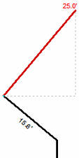
R
25 <ENTER>< ENTER><ENTER>

If the degrees of your turn is more or less than 90º, follow the steps covered in Standard Angles. If your turn will place you back on either a vertical or horizontal line (based upon the palette, not the last line drawn), follow the Basic Drawing steps on page 10.
P
Note: If you need to reverse directions for drawing, ALT will reverse the Point of Beginning.

45º Angles
When drawing 45º angles, activate the 45º tool from the left side of the drawing palette: . All angles will be in 45º increments.
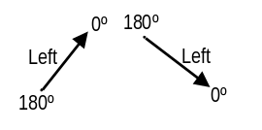

NOTE: No matter what angle a line is drawn, the direction of that line is always 0º.
Right and left are always in relation to the direction you are drawing.
Drawing Curves
Basic Terminology
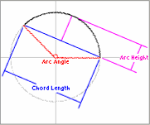
Chord Length – The distance between the two end points of the arc.

Arc Length – The distance around the arc.

Arc Height – The depth from the center of the chord to the highest point of the arc.

Arc Angle – The degree of curvature of the arc (45º, 64º, 90º, etc.).

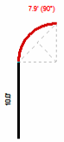
Drawing a Rise and Run Curve
1. When Using the Keyboard First:
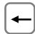
- Enter the Rise (5 ) and the Run (5 ) of the curve.
- Press to activate the curve tool.
F7
- Select the Arc Angle (degree of curvature) or enter a custom degree number: 90º
- Select the direction of the curve (Left or Right) and click OK (use <ENTER> key instead of mouse click for more accuracy).
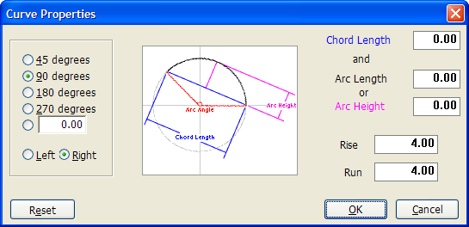
Select the degree of curve desired or enter a custom number of degrees.

Select the Left or Right radio button for the correct direction of the curve.
- Then click <ENTER>< ENTER> (if set on “Manual” Placement Mode) or <ENTER> (if set on “Automatic” Placement Mode) to anchor the curve.
5 5 90º <ENTER> < ENTER><ENTER>
F7 90º

2. When Using the Curve Tool First:
- Press to activate the curve tool.
F7
- You can enter the Rise (4) and the Run (4) of the curve.
Tab
To enter Rise and Run numbers, either:
Place cursor in the Arc Height field
and click . Enter the Rise, and then hit the Tab key to enter Run.
OR
Place the cursor in the Rise field and back space until there is only a “0”. Enter the Rise, and then hit the Tab key to enter Run.

NOTE: Enter a minus sign in front of the Rise or Run for the curve to go the opposite direction:
Rise 4 and Run 4 =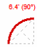 Rise -4 and Run 4= 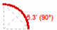 Rise -4 and Run -4 = 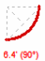 Rise 4 and Run -4 = 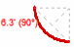

- Select the degrees of arc (curvature) or enter a custom degrees number: 90º
- Select the direction of the curve (Right or Left radio button).
- Click OK (use <ENTER> key).
- Then click <ENTER>< ENTER> (if set on “Manual” Placement Mode) or <ENTER> (if set on “Automatic” Placement Mode) to anchor the curve.

Drawing a Distance, Direction and Deflection Curve
1. When the Arch Angle (degrees of arc) is Known:
- Enter the Distance (Chord Length): 10
- Enter the Direction (Left or Right): L (not arrow)
- Enter the Deflection (Number of degrees left or right of the centerline): 30º
- Click <ENTER>. Do not anchor the angled line.
- Press to activate the curve tool.
F7
  - Select a set number or select and enter the custom number of degrees of arc: 90º
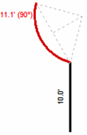
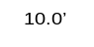
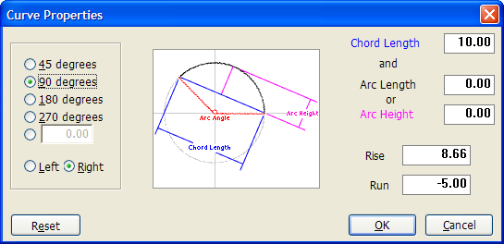
The dimension number on a curve indicates the length of the outside of the curve (Arc Length).
30º
0º
- Click OK (use <ENTER> key).
- Then click <ENTER>< ENTER> (if set on “Manual” Placement Mode) or <ENTER> (if set on “Automatic” Placement Mode) to anchor the curve.
10L30º <ENTER> 90º <ENTER> <ENTER><ENTER>
F7

2. When the Arch Angle (degrees of arc) is NOT Known:
- Enter the Chord Length (Distance): 10
- Enter the Direction (L or R) L
- Enter the Deflection (Number of degrees left or right of the centerline): 30º
- Press to activate the curve tool.
F7
- Enter the Arc Length or Arc Height: 3
(Automatically calculated degrees of arc)
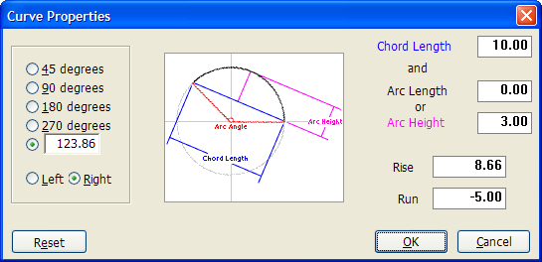

- Click OK (use <ENTER> key) to return to the sketch.
- Then click <ENTER>< ENTER> (if set on “Manual” Placement Mode) or <ENTER> (if set on “Automatic” Placement Mode) to anchor the curve.
10L30º <ENTER> (Enter Arc Length or Height in dialog box) <ENTER> <ENTER><ENTER>
F7

NOTE: No matter what angle a curve is drawn, the direction of the chord length is always 0º.
Right and left are always in relation to the direction you are drawing.
To draw a curve along the same line and then continue the direction of the line after drawing a curve:

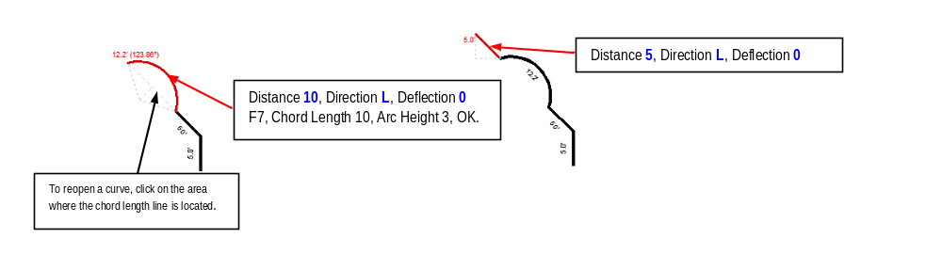

To draw a horizontal or vertical line after a curve has been drawn on an angled line, return to the use of the arrow keys:

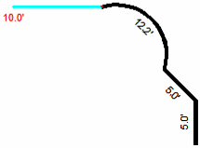
10 <ENTER><ENTER>

Edit a Completed Area
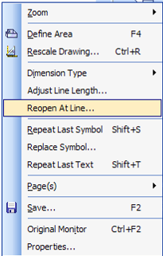
If you need to change a portion of the drawing after the area is completed, highlight the line to be edited, then right click the mouse and select : Make the necessary adjustment and close the drawing again.

Example: Top dimensions should be 20 / 16 / 25.3.

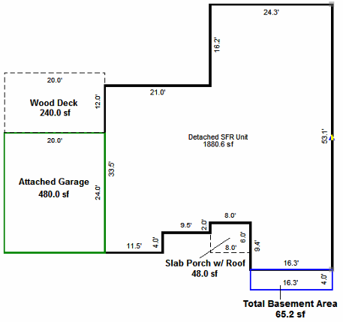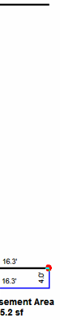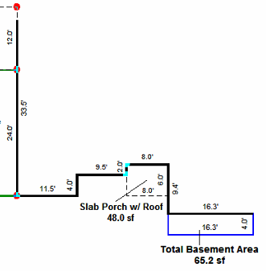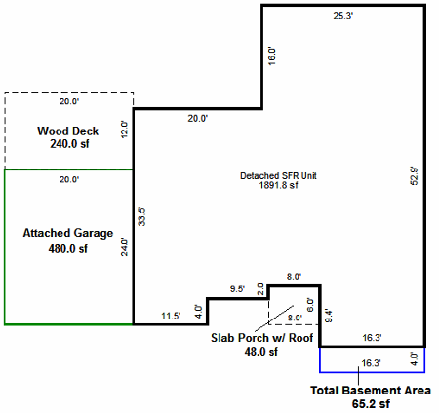
Highlight line to be reopened and right click.
When line is reopened, hit “Delete” until the point of correction is reached.
Enter correct dimensions and hit “A” for Autoclose.

When the font size needs to be reduced or enlarged to read comfortably inside the drawing, highlight the text to be modified and press the Font icon in the top toolbar . Change the font as needed, and then press <ENTER>.
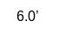
Open Slab Porch
6.0’
When the area drawn is too small to contain the descriptive name (i.e.; Open Slab Porch), move the name outside of the area and draw a line from the name into the area to clearly identify the area being labeled:

Balance of Distance Automatic Calculation
When a line is reopened to modify the area of that line, the system will calculate the remaining line distance after the modification.
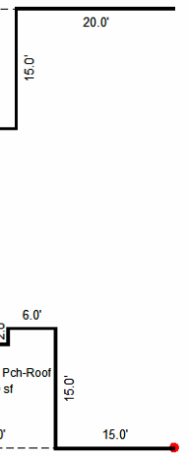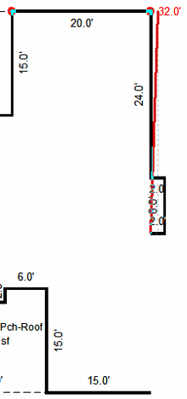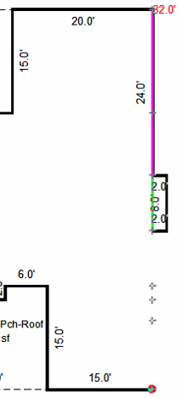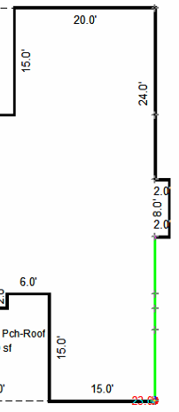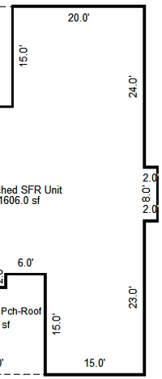
1.
Re-open line to be modified.
2.
Draw revised lines and then place cursor near the POB of the re-opened line.
3.
Press J (jump) to position at POB of re-opened line.
4.
Enter the distance and direction of the line before it was re-opened (55 down).
5.
Anchor line. APEX determines the length of the remaining line automatically (23)
Special Drawing Conditions
Auto-Subtract
There are properties with Main Floor Living Area that does NOT fit within a typical drawing area. In the example below, there are two areas that must be combined into a single MFLA square footage number.
If you attempt to draw both sections as one area, APEX will not calculate lines intersected.
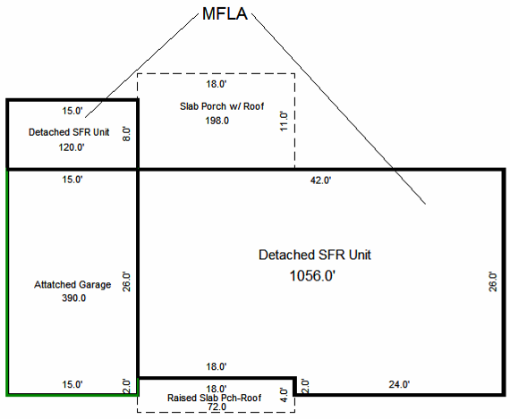
The solution to this problem is as follows:
- Draw the entire perimeter as if it were a single structure. In the example, that includes the garage.
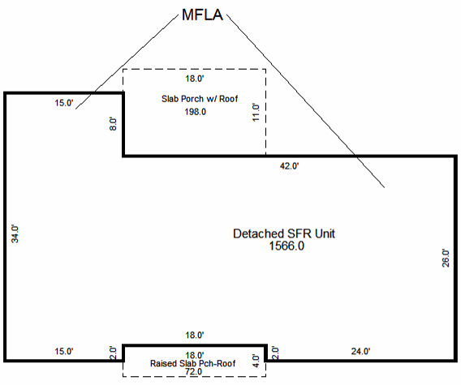
- Define, draw and place the non-MFLA component. In the example, the attached garage.
When you select the specific addition to be drawn, check the Auto-Subtract radio button and verify that the proper code for the MFLA is in the window of the dropdown box below the Auto-Subtract radio button. In the example, the 701 Garage is being Auto-Subtracted from the 1110 Detached SFR Unit.
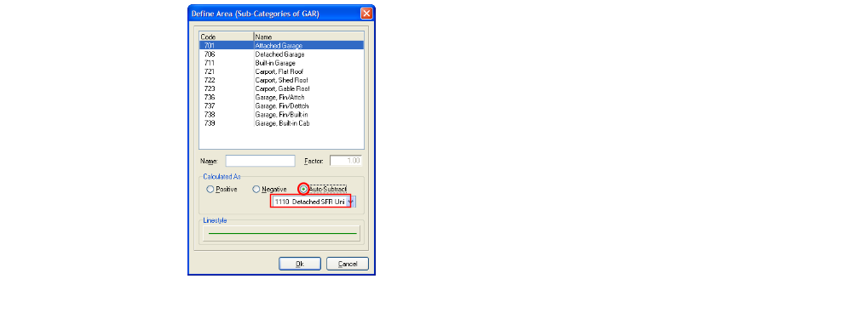

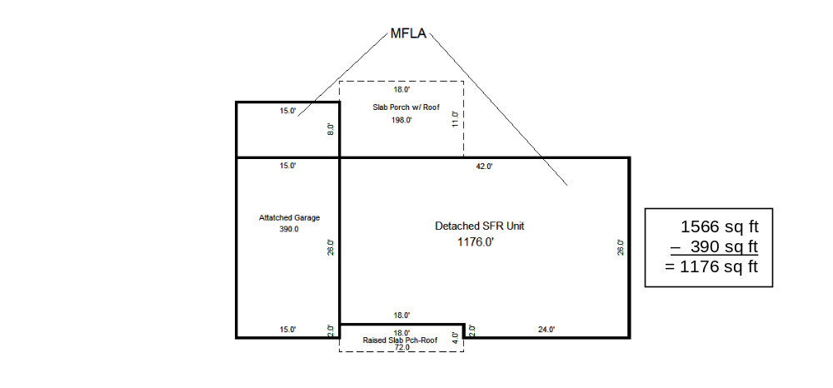
1566 sq ft Perimeter
– 390 sq ft Auto-Subtracted
= 1176 sq ft Total MFLA

Duplicate Multiple Dwellings

When you have multiple dwellings that are the same, you can save the sketch to My Documents and recall it when needed. You will still need to fill in the info screen before saving.

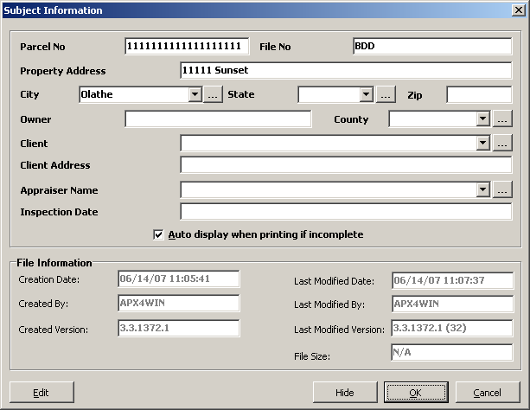

Click File, Save As

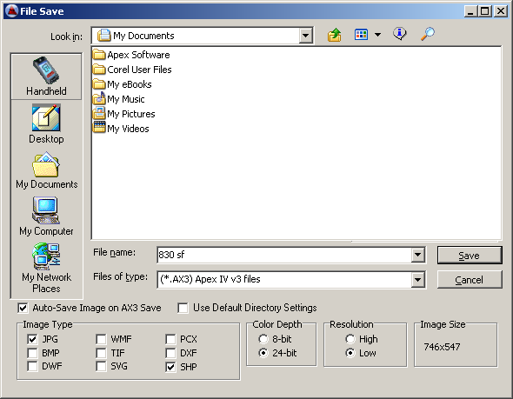

Change Look in: to My Documents.

Rename the file before saving, so you will be able to recognize it easier. Saving to My documents does not save the sketch to the Model and Neighborhood; this will need to be done each time.

Click Save.
When you start a new sketch. Go to File, Open, My Documents and click on the file you saved (830 sf). The sketch will appear.

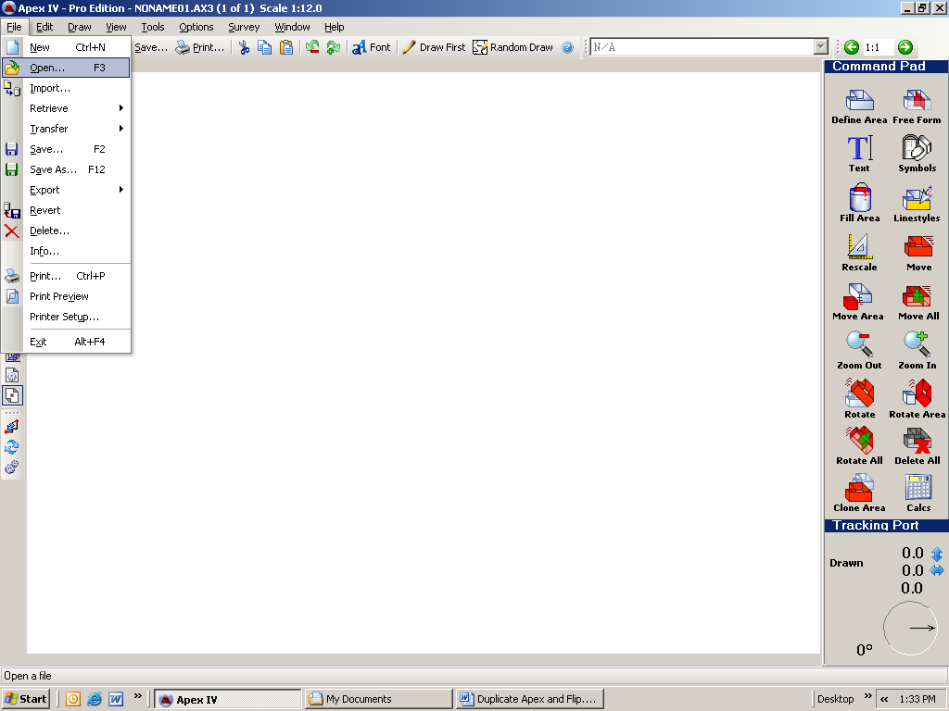

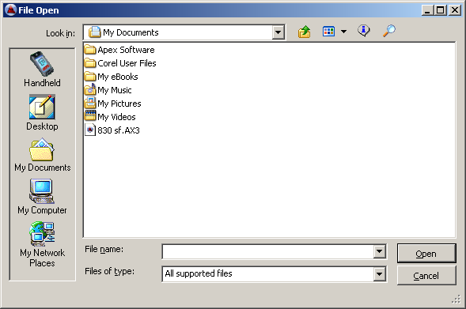

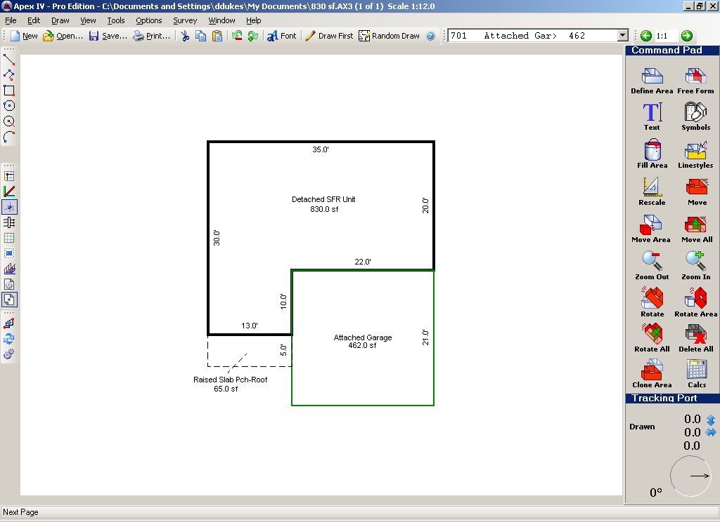

Make any necessary modifications to the sketch, fill in the info screen, and then save to the appropriate Model and Neighborhood.

Flip a Sketch

Go to View, Flip, Left/Right. You can use the previous procedure if the sketch has been saved in my documents.

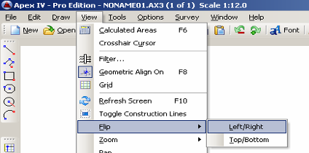

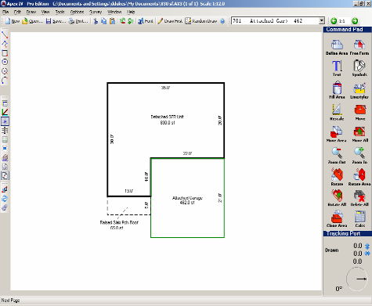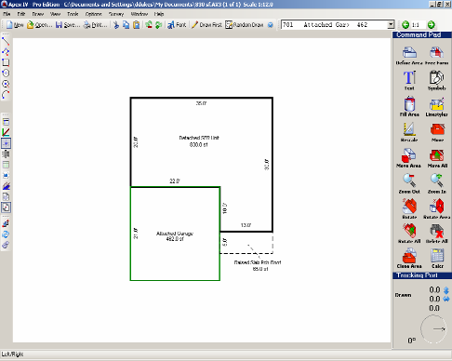

Remember to fill in the info screen and save to the right Model and NBHD.
APEX FUNCTION KEYS
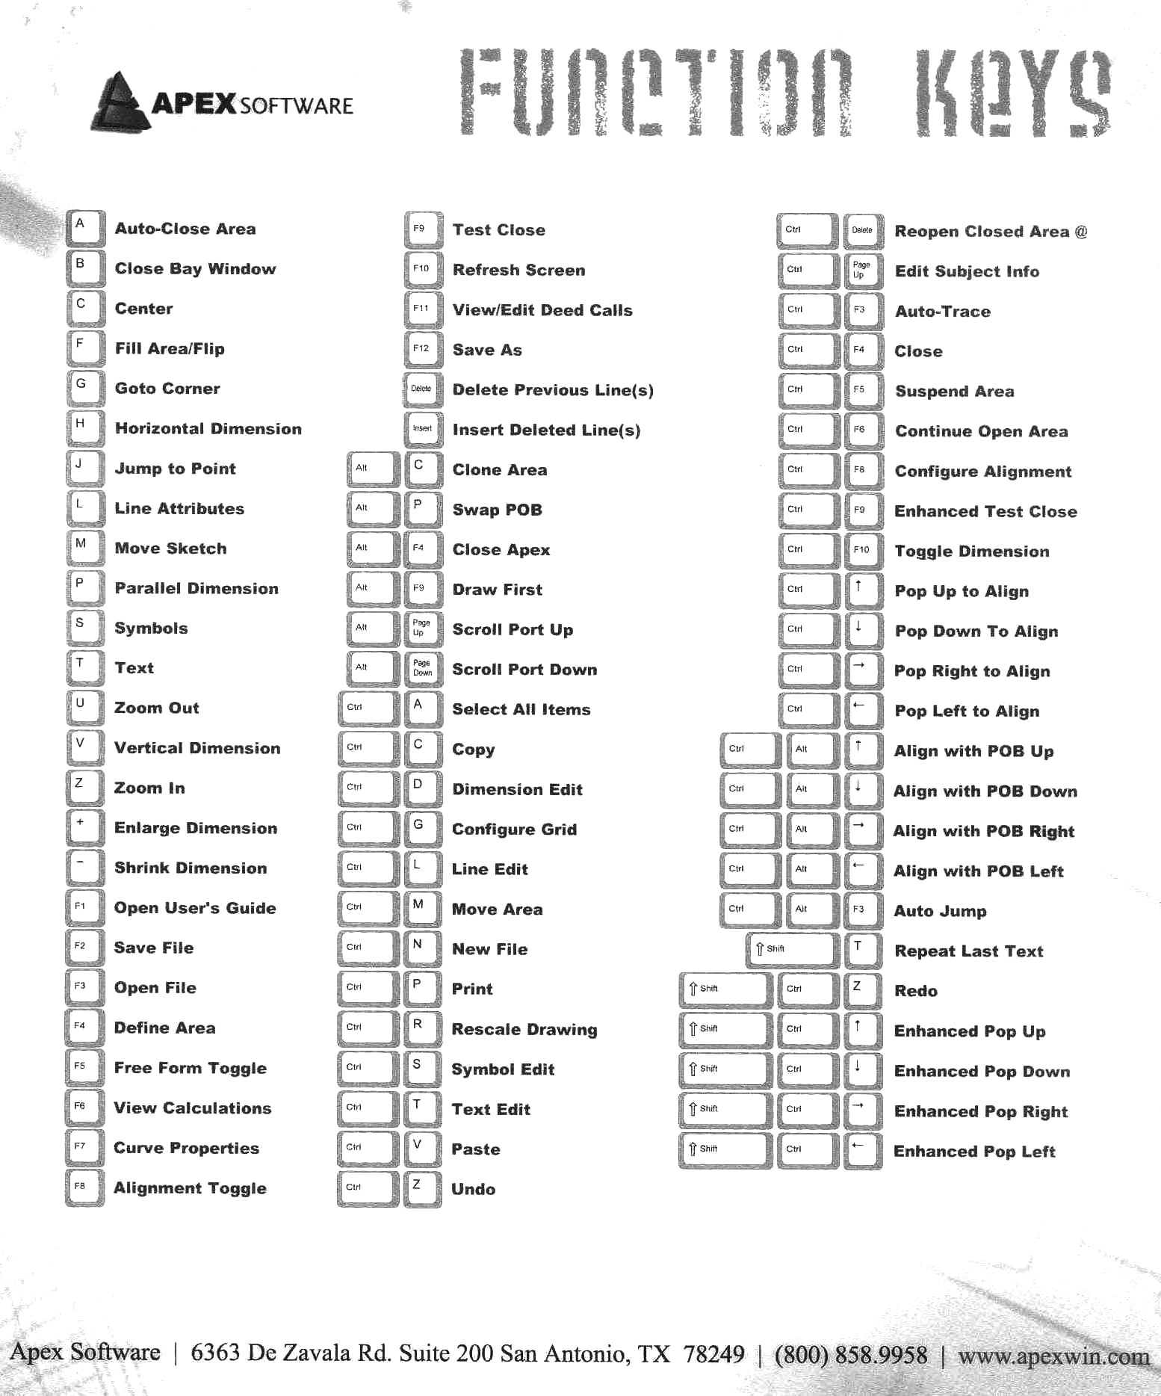

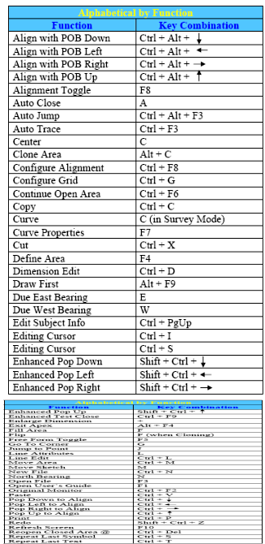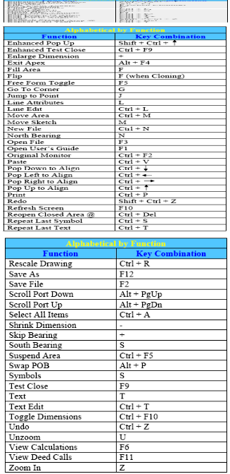
Apex Quick Reference Guide to Most Often Used Processes

Drawing Process
- Define Area to be drawn.
- Position arrow at the point of beginning of drawing.
- Press ENTER to activate pen-down .
- Use keys to draw (in clockwise direction and “Inside” setting).
Action (20 ) ENTER ENTER if “Manual” setting
Action (20 ) ENTER if “Automatic” setting
Options / Configuration / Dimensions

- Complete drawing the area.
- Verify accuracy of drawing and square footage.
- Check placement of dimensions and text for ease of viewing – edit as needed.
- Repeat steps 1 – 7 for each area to be drawn.
- Rescale drawing to fit most of the drawing palette (access Print Preview to check placement when printed).
- Record information: FILE / INFO
- Save Drawing (KUP Number is file name).

Re-Open Drawing Area
- Highlight area to be revised.
- Right click “Reopen at Line.”
- Make revisions and re-save file

Draw Simple Rectangle
- Define Area to be drawn.
- At arrow , keystroke:
  - Width dimension x Height dimension
  - Press ENTER once
  - Move rectangle into position
  - Press ENTER three times to anchor rectangle and text.

Common Keys
Auto-Close Area
A
Close Bay Window
B
Center
C
Jump to Point
J
Delete
Del
Insert
Ins
Auto-Trace
F3
Ctrl
Rescale
R
Ctrl
Define Area
F4
Free Form Mode (draw lines)
F5
Curve Properties
F7

Screen Settings
Optimum screen resolution: Window / Size / 1024 x 768
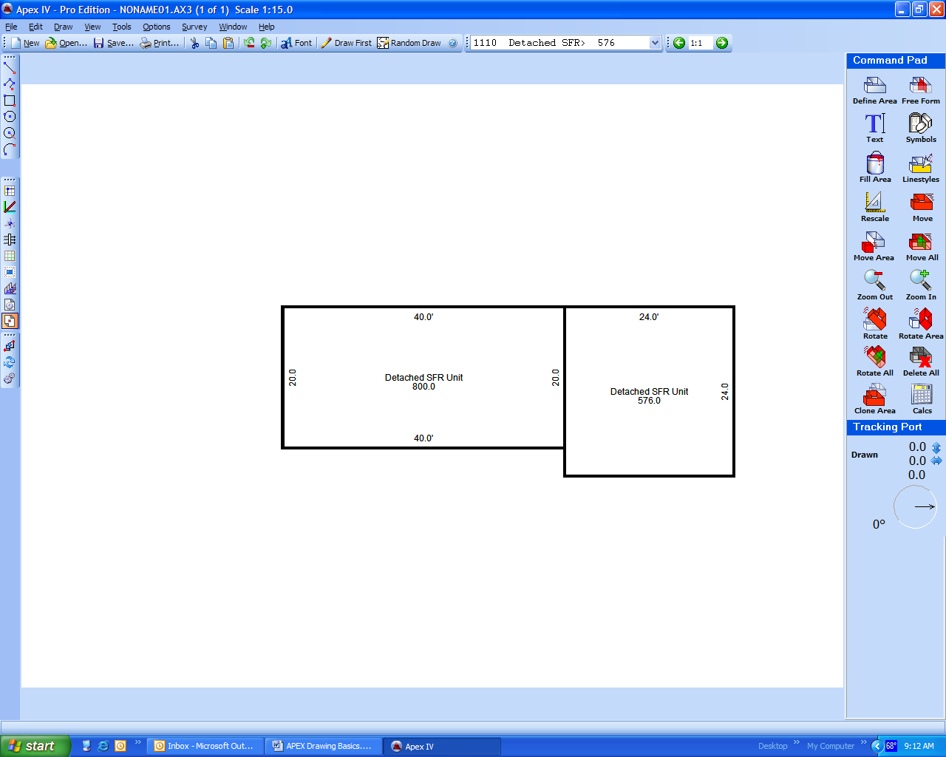
Make APEX full screen:
Move to Starting Location
- Place arrow near end of line.
- Press Jump.
J
- Option 1: With arrow at end of line,
press arrow key one time for each 1 foot of movement to reach starting point on the existing line.
Press ENTER to activate pen-down and commence new area drawing.
- Option 2: With arrow at end of line,
enter the distance to the starting point (10.5) and press arrow key to reach starting point on the existing line.
Press ENTER to activate pen-down and commence new area drawing.
NOTE: Press only arrow key at any time while drawing to move in 1 foot increments (at pen-up or pen-down position).

Change Font Type / Size / Color
- Highlight text to be changed:
- Single text or dimension item.
OR
- Entire area or sketch.
Left click outside of area to be revised.
Hold down left mouse button and drag until red line surrounds area to be revised. Release button.
- Press Font and change the type, size, and/or color.
- Left click outside of the highlighted items to exit the font revision process.

